**From:** Kio, Xi Xiang   
**Sent:** Friday, 22 December, 2017 9:24 AM  
**To:** Chan, Pei-Fong  
**Cc:** Tan, Wee Jian; Tat Shin, Vun; Jack, Fong; Rahamat, Mohd Syaiful Adli; Kok_Hao_Ang  
**Subject:** RE: Addition GHS label for China Labeling

Hi Pei Fong,

Pls find attached for the new form – Pre-printed GHS label retention form.

This form is to be added to current WMS china labeling WO, for SKU 240862 & 491336.

Not sure yet if there will be other SKUs which requires GHS labeling.

Once added into WMS let me know, so we can try.

Thank you.

Kio Xi Xiang (Ms)

Executive - Quality

Contract Logistics/SCM

Schenker Singapore (Pte) Ltd

Tuas Logistics Centre

5 Tuas View Lane, Singapore 637291

DID: +65 6861 1610

Mobile: +65 8228 8825

**WMS Changes:**

## Add new print configuration master

DocType = **DOCCNGHS**

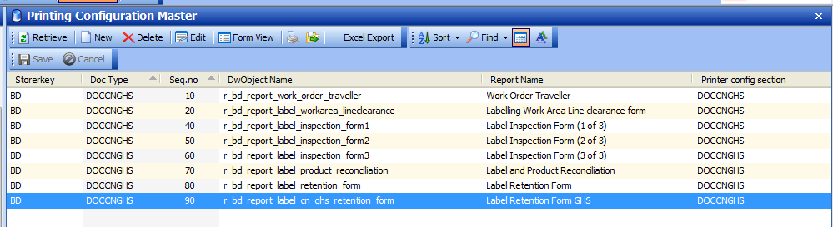

## Customer importer master

Update “**Print Doc Type**” for SKU that require to print Retention GHS form

240862 & 491336

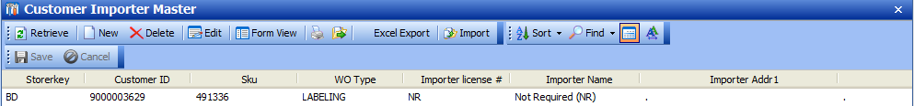

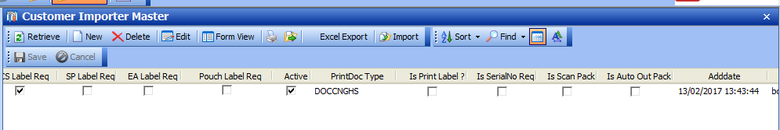

## CN GHS Retention Form

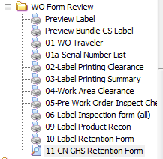

Layout – landscape.

